**create VPC with two subnets , spin up ec2 in both public and private subnets**

**private subnet should not be enabled with public IP**

**connect to ec2 in private subnet using pem key via instance in public subnets**

**CIDR= 20.0.0.0/20**

* With CIDR 20.0.0.0/20 we will have 4096 IPS
* Each subnet will have 2048 IPS
* **Network ID: 20.0.0.0 Broadcast ID: 20.0.15.255**
* Public
  + CIDR Block 20.0.0.0/21
  + Range
    - 20.0.0.0 – 20.0.7.255
* Private
  + CIDR Block 20.0.8.0/21
  + Range
    - 20.0.8.0 – 20.0.15.255

1. VPC
2. Subnets  
   A screenshot of a computer

   AI-generated content may be incorrect.
3. Internet Gateway  
   A screenshot of a computer

   AI-generated content may be incorrect.
4. Route Tables
   1. Public RT
   2. Private RT
5. NAT Gateway  
   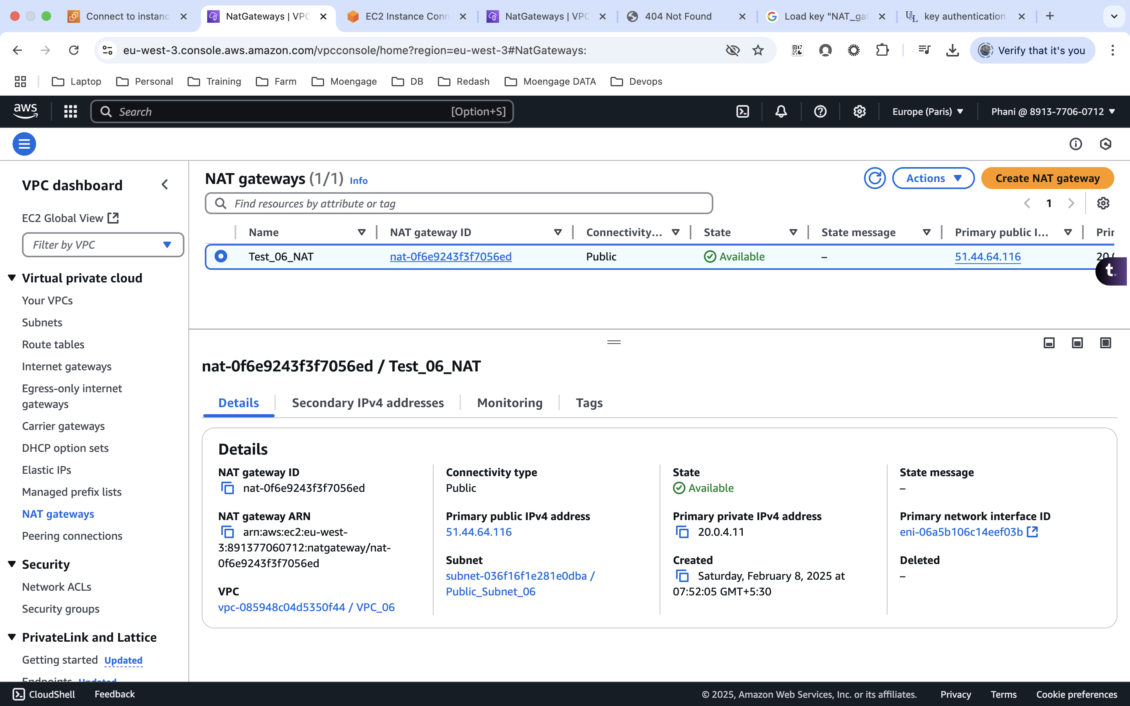  
     
   Update the Private RT with NAT gateway  
   A screenshot of a computer

   AI-generated content may be incorrect.
6. EC2 Instances
   1. Public (Allow SSH)  
      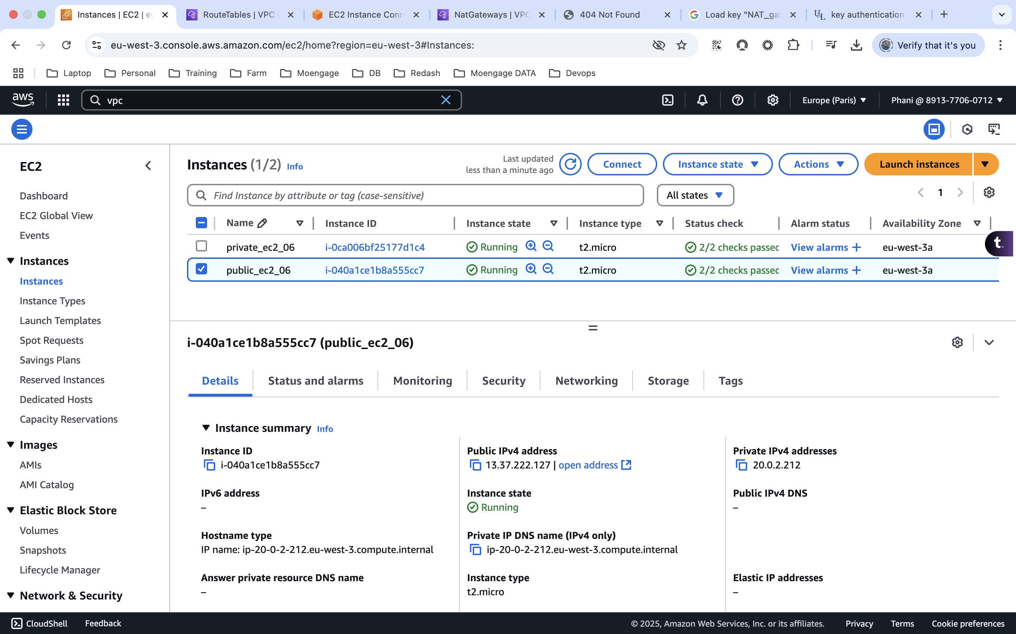
   2. Private (Allow SSH)  
      A screenshot of a computer

      AI-generated content may be incorrect.
7. Trying to connect to public ec2 from the system terminal  
     
     
   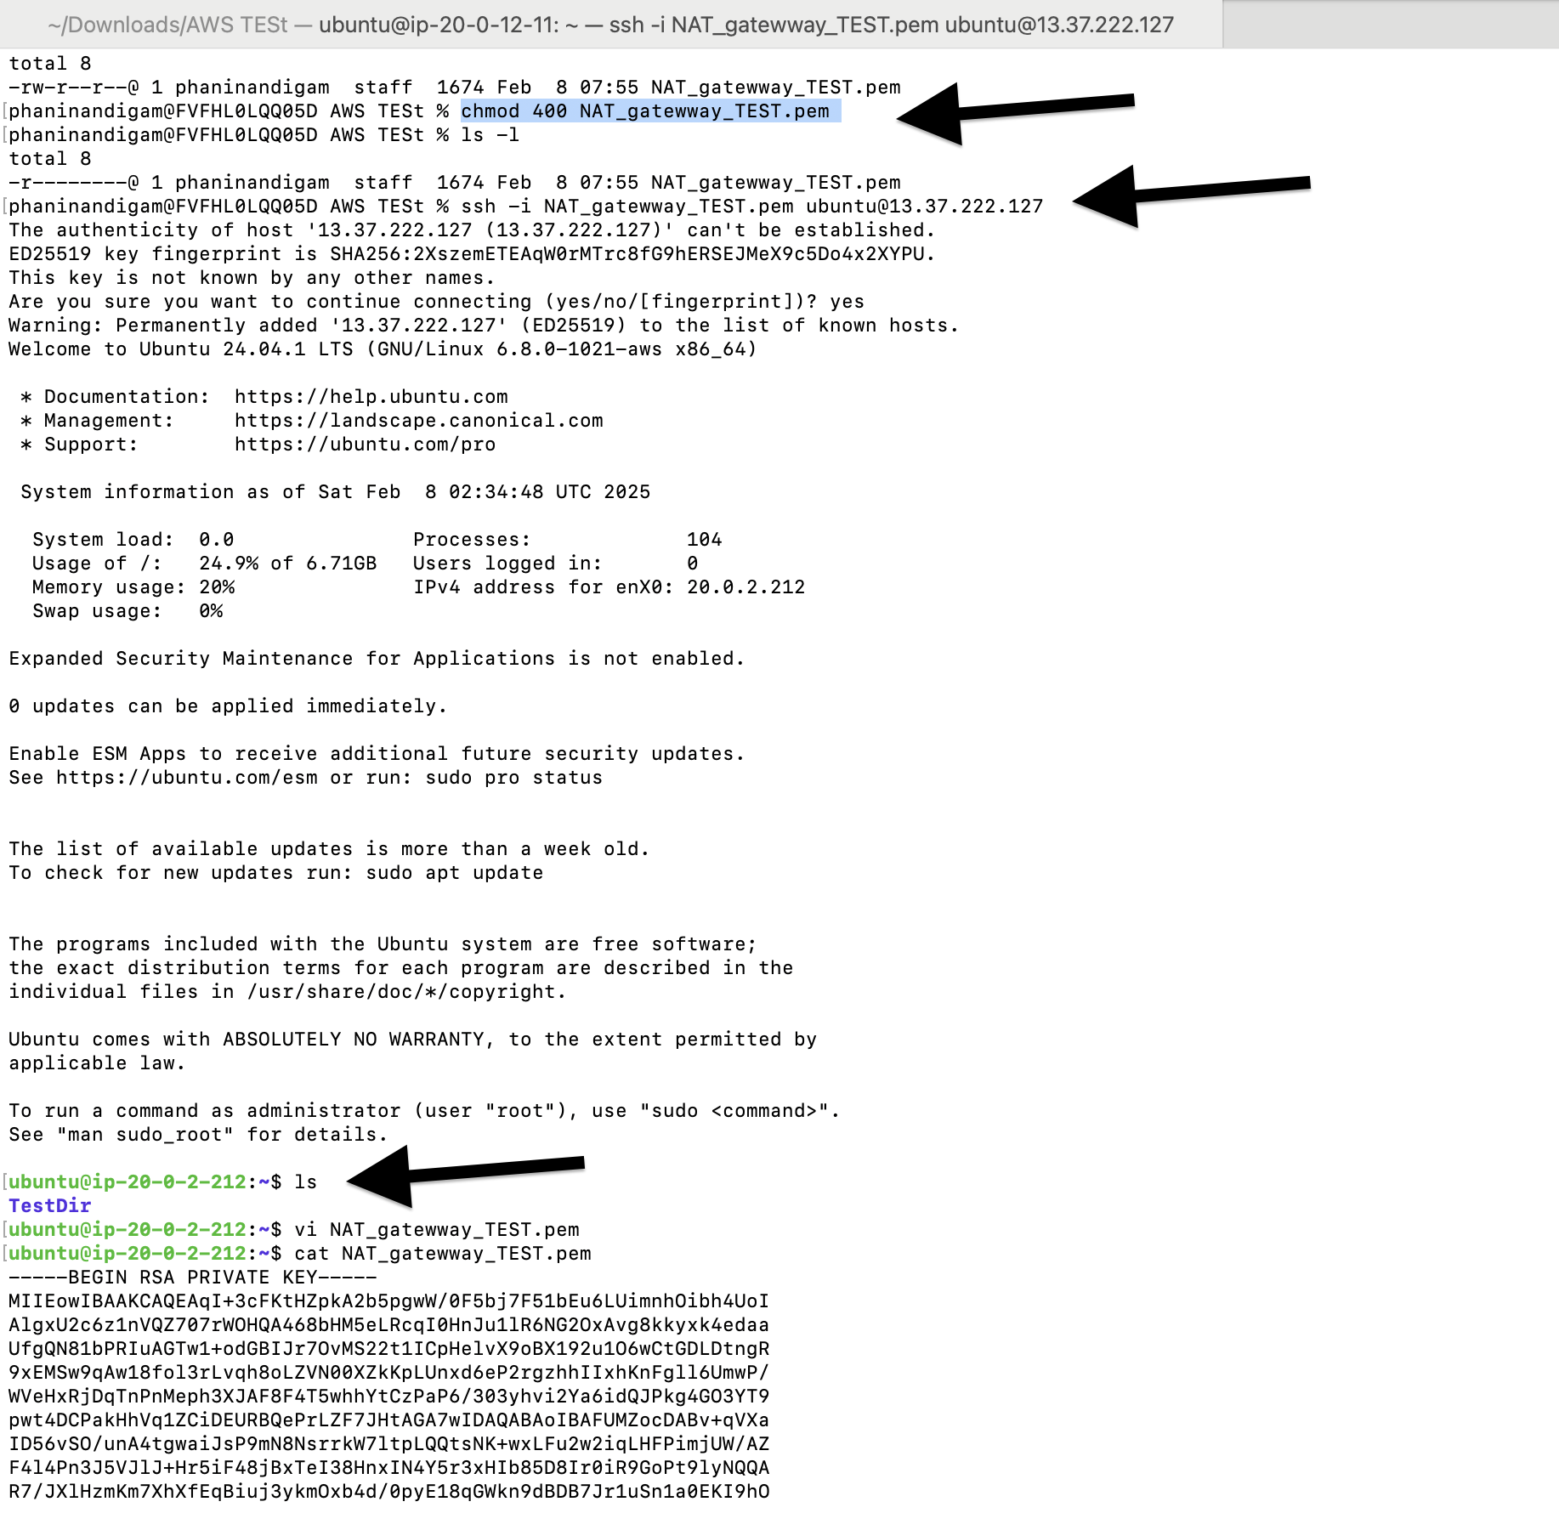
8. Copy pasted the pem file from the local machine to the public machine
9. Accessing the private ec2 from the public ec2 using the pem file  
     
     
     
   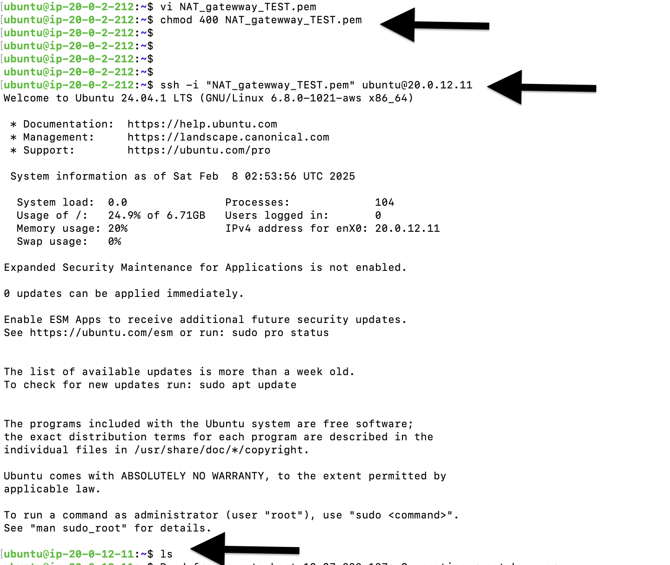  
     
   from EC2 connect:  
   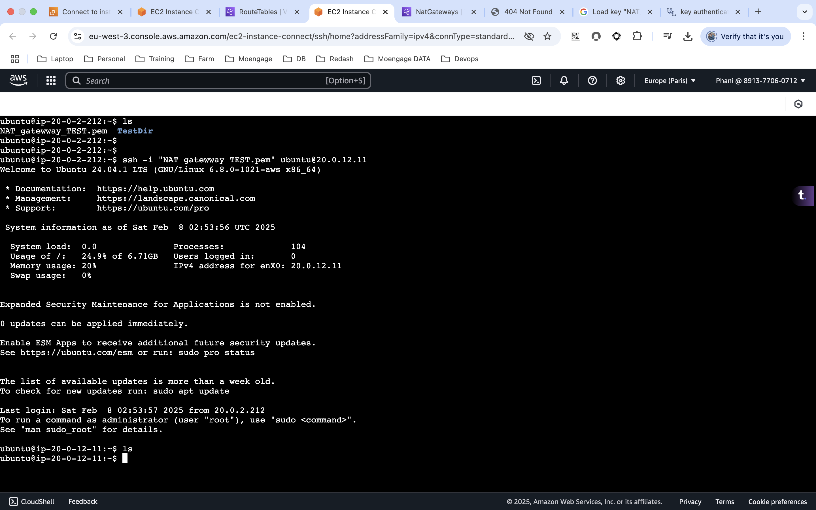

Note: Please go through the below video for more info  
[**https://www.youtube.com/watch?v=ydxEeVAqVdo**](https://www.youtube.com/watch?v=ydxEeVAqVdo)